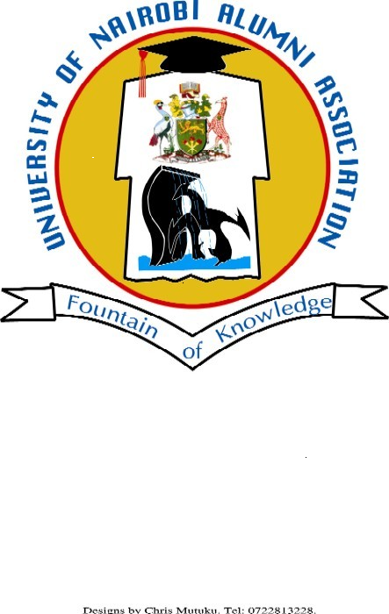
UNIVERSITY OF NAIROBI ALUMNI ASSOCIATION
ADDRESS BY THE CHAIRMAN, UONAA, DURING THE
68th UNIVERSITY OF NAIROBI GRADUATION CEREMONY – FRIDAY 16th DEC 2022

The Chancellor, UoN, Dr. Vijoo Rattansi
The Chairperson, UON Council, Prof. Miriam Were
Members of the University Council
Vice-Chancellor, Prof. Stephen Kiama
Deputy Vice Chancellor, Academic Affairs,
Associate Vice Chancellor, Research, Innovation & Enterprise,
Chief Operations Officer,
Deans and Associate Deans of Faculties,
Chairpersons of Departments
The Academic Fraternity
Other Distinguished guests present
Fellow Alumni of the University of Nairobi
Parents, Guardians and Graduands:
Ladies and Gentlemen.

Good morning,
On behalf of the University of Nairobi Alumni Association and as a proud alumni of this great University, It is my humble pleasure to join the entire University fraternity and all invited guests and stakeholders for this 68th Graduation Ceremony.
I take this opportunity to congratulate all the graduands for this important milestone you have made to ensure academic success. This is a great achievement for you, your families, your community, your Country and more so the global community.
I also take this opportunity to thank and recognize the University of Nairobi Management, academic, non-academic staff, University partners and parents and guardians.
The 11 Faculties who dedicated all their energies to ensure your successful completion leading to today’s celebrations need to be recognized: i.e
- Faculty of Agriculture
- Faculty of Arts & Social Sciences
- Faculty of Built Environment and design
- Faculty of Business and Management Sciences
- Faculty of Education
- Faculty of Engineering
- Faculty of Health Sciences
- Faculty of Law
- Faculty of Science & Technology
- Faculty of Veterinary Medicine
As a proud alumni of this prestigious University, I encourage you to utilize the skills, competencies and knowledge acquired during your academic time at the University to transform our communities and country and make the world a better place.
As our theme for this year resonates “Promoting Innovations & Entrepreneurship for Sustainable Development” I take this opportunity to challenge you to venture into the world of Innovation and Entrepreneurship whether you go directly into Employment or into Business. This is one of the best ways of making a significant impact to our societies and our country at large.
And I quote from Vice President of the U.S Khamala Harris at the U.S. African and Diaspora Young Leaders Summit on December 14, 2022
‘So, Africa cannot help but be in the future business. I strongly believe that the creativity and ingenuity of Africa’s young leaders will help us shape the future of the world, and that their ideas your ideas and innovations and initiatives will benefit the entire world’.
Recently, our Alma Mater has hosted prominent scholars and distinguished personalities who have shared their views in the world of Innovation and Entrepreneurship. There is hope that improvements will happen faster and last longer if all efforts are channeled to the right direction.
Ladies and gentlemen, as you set foot into the world of work, I wish to encourage you to put into practice all you have learnt in your college life to create positive impact in our society.
I know that sometimes opportunities for jobs, internship and entrepreneurship may not be forthcoming, but be focused, interact and connect with your alma mater and other colleague’s to enhance your chances of getting jobs and other fruitful engagements.
For the Association, we will continue to support our Alma Mater and all related initiatives geared towards producing graduates that will fit it to the job market and have values that are acceptable and desired in the society.
The Association continues to applaud the excellent job the University has continued to do with regards to maintaining the world class status of the Institution. And true to our vision of ‘A World Class University Committed to Scholarly Excellence’ Our Alumni has continued to shine in strategic positions and in diverse circumstances.
This is the University that has produced our country’s top leadership led by H.E the President of the Republic of Kenya-Hon. William Samoei Ruto, his deputy Hon. Rigathi Gachagua members of the Executive, the Legislature, the Judiciary and leaders in other critical sectors across the country and beyond.
Ladies and Gentlemen,
The UoN Alumni Association recently conducted a very successful Annual General Meeting (AGM) and elections of the nine (9) members of the Executive Committee. These activities were conducted professional and successfully with the assistance of the UoN ICT Department. Details about the events and other critical information concerning the association can be found on the Alumni website.
The Association will continue supporting the university the following iniatives plus others to be planned;
- Support towards the launch UoN Foundation
- Support towards the Annual Nairobi Innovation week
- Support towards the Nairobi International Trade fair
- Rewarding the top performing students in all the faculties every academic year
- Yearly scholarship fund of KShs 2,000,000 towards supporting bright but needy students.
- support for students’ mentorship programmes
- University sports activities among others
On scholarship fund for bright but needy students, the Association shall be rolling out the advertisement to welcome applications from bright and needy students in early 2023.
Our symbiotic relationship remains and will even grow stronger as we continue to forge more innovative and sustainable ways of engaging stakeholders and other partners. As you graduate today, I encourage you to join University of Nairobi Alumni Association. For this is one of the best professional platforms to help you expand your networks, grow professional and support your University towards World Class Status.
For more information about the alumni association, you can visit our website or follow us on our social media pages and also encourage your fellow comrades to join the alumni community.
Please find time and visit the Alumni table outside Taifa Hall and join us today as a member.
Our slogan is ‘Our Alumni our strength”
Wish you a Merry Christmas and a prosperous New Year 2023.
Asante sana.
Isaac Awuondo
CHAIRMAN
UNIVERSITY OF NAIROBI ALUMNI ASSOCIATION.

